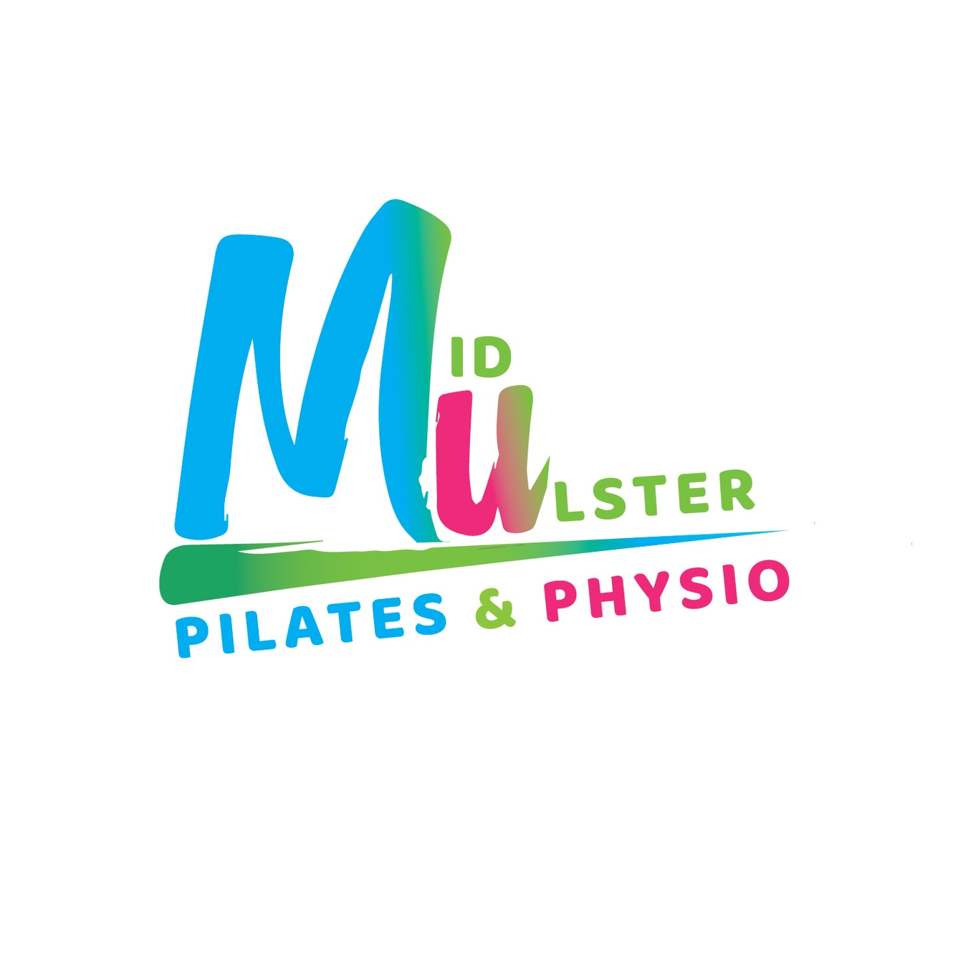

Due to continued growth including development into online services, Mid-Ulster Pilates & Physiotherapy is keen to recruit an Administrative Assistant to join our small team and support our general business activities. This is a new Full Time Permanent role.

Job Title: Administrative Assistant

Reports To;
The Administrator will report to the owners of Mid Ulster Pilates & Physiotherapy, Mary Angela & Kathy. The administrator also will work under the guidance of the Practice Manager.

Job Overview

The Administrator will be responsible for the daily running of a very busy Woman’s Health Physiotherapy Clinic, including the duties below;

General Responsibilities and Duties;

- Responding to messages on various platforms including Facebook, Instagram and email
- Greeting clients attending clinic appointments
- Arranging appointments via phone call
- Cash-handling and documentation
- Signposting clients to the correct service within clinic/classes
- Responsibility for monitoring and re-ordering stock
- Administrative management of block bookings of online and studio Pilates classes using our software package.
- Managing confidential client details
- Updating social media posts as required
- Attending staff meetings and staff training sessions as necessary – in person or via zoom
- Adhering to company policies and procedures
- Any other reasonable duties as requested by owners or Practice Manager

Essential Criteria

- Confident at dealing with client enquiries
- Excellent time management and organisational skills
- Strong interpersonal and communication skills
- Previous experience in the use of social media as a business tool
- Flexible work approach
Desirable Criteria
Preference may be given to applicants who can demonstrate;
- At least 6 months Administrative experience - including the use of Microsoft Office Experience.
- Previous experience processing or handling confidential client / customer information
- Previous experience in a client / customer facing role

Additional Job Details

The position will commence asap with a probationary period of 3month. The starting rate of pay is £9.00 per hour.

37.5hrs, 5 days per week Monday – Friday (will include one Saturday a month), flexibility is important to fulfil the needs of the role, hours can be agreed with the successful candidate

Mid Ulster Pilates & Physiotherapy operate out of two venues, The Station House, Knockloughrim & Moneymore. Initially the role will be based at our Station House venue, Knockloughrim, BT45 8PS.

Further detail can be discussed at interview Stage.

How to Apply

Please ensure you detail within your CV or cover letter how you meet the essential or desirable criteria to aid shortlisting.

Email your CV to: midulsterpilates@gmail.com

Closing date for applications Friday 25th June 12 Noon.

Provisional interview date scheduled for Friday 2nd July

